**Name:** Muhammed Essam **ID:** 20190462

**Name:** Fatema Hesham  **ID:** 20190373

***Mnist dataset:***

The MNIST dataset is an acronym that stands for the Modified National Institute of Standards and Technology dataset. It is a dataset of 60,000 small square 28×28 pixel grayscale images of handwritten single digits between 0 and 9.

**Sample of training** = 15000, **sample of testing** = 10000

***CNN:***

1. Model first Structure:

* Convolutions layers = 3 layers using max_pooling ((2,2),stride=2) and activation function after each layer (“Relu”)
  + Num_channels on layer 1 = 50
  + Num_channels on layer 2 = 88
  + Num_channels on layer 3 = 120
* Fully connected layers = 3 layers and output layer using activation function in hidden layer (“Relu”) and (“Softmax”) on output layer
  + Num_neurals on layer 1 = 120
  + Num_ neurals on layer 2 = 512
  + Num_ neurals on layer 3 = 256
  + Num_ neurals on output layer = 10
* Optimizer = SGD, learning rate = 0.0009
* Batch size = 32
* 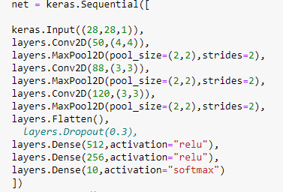

***Find best epochs:***

Number of epochs we try is in range of [10:30] and best models in range of [10:20].

From

1. Model 1:

* Number of epochs =14
* Final accuracy on train = 99.9
* Final accuracy on test = 96.4
* Accuracy in first 5 epochs
  + Epoch 1/14
  + accuracy: 0.8056
  + Epoch 2/14
  + accuracy: 0.9302
  + Epoch 3/14
  + accuracy: 0.9533
  + Epoch 4/14
  + accuracy: 0.9673
  + Epoch 5/14
  + accuracy: 0.9772
* Number of parameters:
  + Total params: 331,548
  + Trainable params: 331,548
* Avg_time in each epoch for training data = 21s
* Testing time = 4s

1. Model 2:

* Number of epochs = 16
* Final accuracy on train = 99.9
* Final accuracy on test = 96.77
* Accuracy in first 5 epochs
  + Epoch 1/16
  + accuracy: 0.8021
  + Epoch 2/16
  + accuracy: 0.9221
  + Epoch 3/16
  + accuracy: 0.9471
  + Epoch 4/16
  + accuracy: 0.9591
  + Epoch 5/16
  + accuracy: 0.9683
* Number of parameters:
  + Total params: 331,548
  + Trainable params: 331,548
* Avg_time in each epoch for training data = 21s
* Testing time = 4s

1. Model 3:

* Number of epochs = 26
* Final accuracy on train = 100.00%
* Final accuracy on test = 96.81%
* Accuracy in first 5 epochs
  + Epoch 1/26
  + accuracy: 0.8171
  + Epoch 2/26
  + accuracy: 0.9331
  + Epoch 3/26
  + accuracy: 0.9567
  + Epoch 4/26
  + accuracy: 0.9690
  + Epoch 5/26
  + accuracy: 0.9775
* Number of parameters:
  + Total params: 331,548
  + Trainable params: 331,548
* Avg_time in each epoch for training data = 19 s
* Testing time = 4s

1. Model 4:

* Number of epochs = 19
* Final accuracy on train = 100.00%
* Final accuracy on test = 96.7%
* Accuracy in first 5 epochs
  + Epoch 1/19
  + accuracy: 0.8055
  + Epoch 2/19
  + accuracy: 0.9276
  + Epoch 3/19
  + accuracy: 0.9535
  + Epoch 4/19
  + accuracy: 0.9637
  + Epoch 5/19
  + accuracy: 0.9735
* Number of parameters:
  + Total params: 331,548
  + Trainable params: 331,548
* Avg_time in each epoch for training data = 21 s
* Testing time = 4s

Conclusion and observation:

* Accuracy increasing with the increase of number of epochs
* After 16 epochs time increasing and accuracy almost same but at 26 epochs accuracy will be 96.8% with time more than 16. At sample time with epoch = 320

At sample time with 26 epochs = 500

**So best model with 16 epochs**

***Changing in learning rate:***

1. Model 5:

* Learning rate = 0.002
* Final accuracy on train = 100.00%
* Final accuracy on test = 96.9%
* Accuracy in first 5 epochs
  + 1/16
  + accuracy: 0.8010
  + Epoch 2/16
  + accuracy: 0.9418
  + Epoch 3/16
  + accuracy: 0.9634
  + Epoch 4/16
  + accuracy: 0.9750
  + Epoch 5/16
  + accuracy: 0.9831
* Number of parameters:
  + Total params: 331,548
  + Trainable params: 331,548
* Avg_time in each epoch for training data = 14s
* Testing time = 4s

1. Model 6:

* Learning rate = 0.001
* Final accuracy on train = 100.00%
* Final accuracy on test = 96.7%
* Accuracy in first 5 epochs
  + Epoch 1/16
  + accuracy: 0.8145
  + Epoch 2/16
  + accuracy: 0.9335
  + Epoch 3/16
  + accuracy: 0.9573
  + Epoch 4/16
  + accuracy: 0.9699
  + Epoch 5/16
  + accuracy: 0.9785
* Number of parameters:
  + Total params: 331,548
  + Trainable params: 331,548
* Avg_time in each epoch for training data = 15 s
* Testing time = 4s

1. Model 7:

* Learning rate = 0.0005
* Final accuracy on train = 99.7
* Final accuracy on test = 95.7%
* Accuracy in first 5 epochs
* Epoch 1/16
* accuracy: 0.7908
* Epoch 2/16
* accuracy: 0.9167
* Epoch 3/16
* accuracy: 0.9438
* Epoch 4/16
* accuracy: 0.9556
* Epoch 5/16
* accuracy: 0.9649
* Number of parameters:
  + Total params: 331,548
  + Trainable params: 331,548
* Avg_time in each epoch for training data = 17s
* Testing time = 4s

1. Model 8:

* Learning rate = 0.0007
* Final accuracy on train = 99.9%
* Final accuracy on test = 96.2%
* Accuracy in first 5 epochs
* Epoch 1/16
* accuracy: 0.7893
* Epoch 2/16
* accuracy: 0.9202
* Epoch 3/16
* accuracy: 0.9446
* Epoch 4/16
* accuracy: 0.9603
* Epoch 5/16
* accuracy: 0.9691
* Number of parameters:
  + Total params: 331,548
  + Trainable params: 331,548
* Avg_time in each epoch for training data = 16s
* Testing time = 4s

Conclusion and observation:

* Best accuracy and best avg_time at learning rate = 0.002
* Total time = 242

**So best model with 16 epochs and learning rate =0.002**

***Changing CNN kernel’s size:***

1. Model 9:

* At first layer changing to (2,2)
* At second layer changing to (3,3)
* At second layer changing to (2,2)
* Final accuracy on train = 100.00%
* Final accuracy on test = 97.67
* Accuracy in first 5 epochs
  + Epoch 1/16
  + accuracy: 0.8449
  + Epoch 2/16
  + accuracy: 0.9533
  + Epoch 3/16
  + accuracy: 0.9722
  + Epoch 4/16
  + accuracy: 0.9841
  + Epoch 5/16
  + accuracy: 0.9889
* Number of parameters:
  + Total params: 395,866
  + Trainable params: 395,866
* Avg_time in each epoch for training data = 21s
* Testing time = 6s

***Changing in CNN number of channels and number of neurons:***

10. Model 10:

* Number of channels at first layer = 128
* Number of channels at second layer = 88
* Number of channels at third layer = 120
* Final accuracy on train = 100.00%
* Final accuracy on test = 97.6%
* Accuracy in first 5 epochs
* Epoch 1/16
* accuracy: 0.8143
* Epoch 2/16
* accuracy: 0.9446
* Epoch 3/16
* accuracy: 0.9628
* Epoch 4/16
* accuracy: 0.9760
* Epoch 5/16
* accuracy: 0.9841
* Number of parameters:
  + Total params: 267,682
  + Trainable params: 267,682
* Avg_time in each epoch for training data = 41s
* Testing time = 6s

1. Model 11:

Begin with this structure

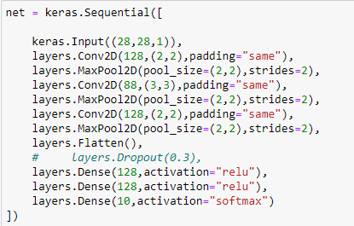

* Final accuracy on train = 100.00%
* Final accuracy on test = 97.3%
* Accuracy in first 5 epochs
  + Epoch 1/16
  + accuracy: 0.8189
  + Epoch 2/16
  + accuracy: 0.9435
  + Epoch 3/16
  + accuracy: 0.9635
  + Epoch 4/16
  + accuracy: 0.9721
  + Epoch 5/16
  + accuracy: 0.9815
* Number of parameters:
  + Total params: 230,754
  + Trainable params: 230,754
* Avg_time in each epoch for training data = 43s
* Testing time = 9s

***Try to set an activation function after each conv. layer:***

1. Model 12:

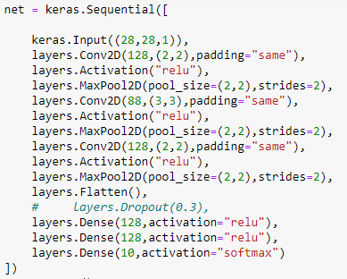

* Final accuracy on train = 100.00%
* Final accuracy on test = 98.17%
* Accuracy in first 5 epochs
  + Epoch 1/16
  + accuracy: 0.8616
  + Epoch 2/16
  + accuracy: 0.9518
  + Epoch 3/16
  + accuracy: 0.9685
  + Epoch 4/16
  + accuracy: 0.9767
  + Epoch 5/16
  + accuracy: 0.9830
* Number of parameters:
  + Total params: 312,674
  + Trainable params: 312,674
* Avg_time in each epoch for training data = 50s
* Testing time = 12s

***Changing on the number of layer, number of channels and number of neurons:***

1. Model 13:

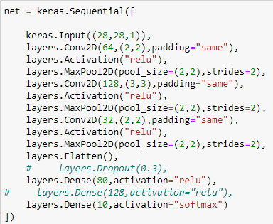

* Final accuracy on train = 100.00%
* Final accuracy on test = 97.79%
* Accuracy in first 5 epochs
  + Epoch 1/16
  + accuracy: 0.7871
  + Epoch 2/16
  + accuracy: 0.9416
  + Epoch 3/16
  + accuracy: 0.9592
  + Epoch 4/16
  + accuracy: 0.9681
  + Epoch 5/16
  + accuracy: 0.9718
* Number of parameters:
  + Total params: 114,522
  + Trainable params: 114,522
* Avg_time in each epoch for training data = 36s
* Testing time = 6s

Conclusion and observation:

* Best is model 12

***Try best activation function:***

1. Model 14:

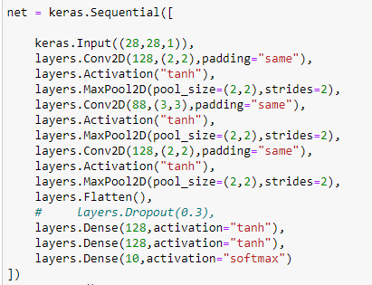

* Final accuracy on train = 100.00%
* Final accuracy on test = 97.2%
* Accuracy in first 5 epochs
  + Epoch 1/16
  + accuracy: 0.6603
  + Epoch 2/16
  + accuracy: 0.8749
  + Epoch 3/16
  + accuracy: 0.9177
  + Epoch 4/16
  + accuracy: 0.9371
  + Epoch 5/16
  + accuracy: 0.9458
* Number of parameters:
  + Total params: 312,674
  + Trainable params: 312,674
* Avg_time in each epoch for training data = 55s
* Testing time = 12s

1. Model 15:

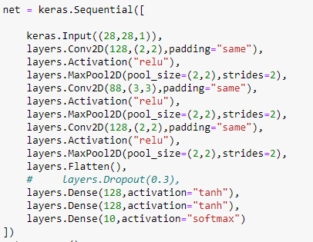

* Final accuracy on train = 100.00%
* Final accuracy on test = 97.69%
* Accuracy in first 5 epochs
* Epoch 1/16
* accuracy: 0.7509
* Epoch 2/16
* accuracy: 0.9215
* Epoch 3/16
* accuracy: 0.9460
* Epoch 4/16
* accuracy: 0.9536
* Epoch 5/16
* accuracy: 0.9637
* Number of parameters:
  + Total params: 312,674
  + Trainable params: 312,674
* Avg_time in each epoch for training data = 48s
* Testing time = 10s

1. Model 16:

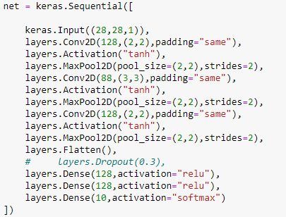

* Final accuracy on train = 97.14%
* Final accuracy on test = 97.14%
* Accuracy in first 5 epochs
* Epoch 1/16
* accuracy: 0.5183
* Epoch 2/16
* accuracy: 0.8005
* Epoch 3/16
* accuracy: 0.8793
* Epoch 4/16
* accuracy: 0.9140
* Epoch 5/16
* accuracy: 0.9331
* Number of parameters:
  + Total params: 312,674
  + Trainable params: 312,674
* Avg_time in each epoch for training data = 51s
* Testing time = 11s

1. Model 17:



* Final accuracy on train = 100.00%
* Final accuracy on test = 97.69%
* Accuracy in first 5 epochs
* Epoch 1/16
* accuracy: 0.7509
* Epoch 2/16
* accuracy: 0.9215
* Epoch 3/16
* accuracy: 0.9460
* Epoch 4/16
* accuracy: 0.9536
* Epoch 5/16
* accuracy: 0.9637
* Number of parameters:
  + Total params: 312,674
  + Trainable params: 312,674
* Avg_time in each epoch for training data = 48s
* Testing time = 10s